Aim
To write a Python program to solve the 8 Puzzle Problem.

Algorithm
- Start.
- Create a 3 × 3 puzzle.
- Display the initial puzzle.
- Find the blank space (0).
- Swap the blank tile with the adjacent tile.
- Display the puzzle after the move.
- Stop.
PROGRAM
from heapq import heappush, heappop
GOAL = ((1, 2, 3),
(4, 5, 6),
(7, 8, 0))
def heuristic(state):
distance = 0
for i in range(3):
for j in range(3):
value = state[i][j]
if value != 0:
goal_x = (value - 1) // 3
goal_y = (value - 1) % 3
distance += abs(i - goal_x) + abs(j - goal_y)
return distance
def find_blank(state):
for i in range(3):
for j in range(3):
if state[i][j] == 0:
return i, j
def get_neighbors(state):
x, y = find_blank(state)
directions = [(-1, 0), (1, 0), (0, -1), (0, 1)
neighbors = []
for dx, dy in directions:
nx, ny = x + dx, y + dy

if 0 <= nx < 3 and 0 <= ny < 3:
new_state = [list(row) for row in state]
new_state[x][y], new_state[nx][ny] = \
new_state[nx][ny], new_state[x][y]
neighbors.append(tuple(tuple(row) for row in new_state))
return neighbors
def solve_puzzle(start):
pq = []
heappush(pq, (heuristic(start), 0, start, []))
visited = set()
while pq:
f, g, state, path = heappop(pq)
if state in visited:
continue
visited.add(state)
if state == GOAL:
return path + [state]

for neighbor in get_neighbors(state):
if neighbor not in visited:
new_g = g + 1
new_f = new_g + heuristic(neighbor)
heappush(pq, (new_f, new_g,
neighbor,
path + [state]))
return None
def print_state(state):
for row in state:
print(row)
print()
solution = solve_puzzle(start_state)
if solution:
print(f"Solution found in {len(solution)-1} moves:\n")
for step in solution:
print_state(step)
else:
print("No solution exists.")

OUTPUT
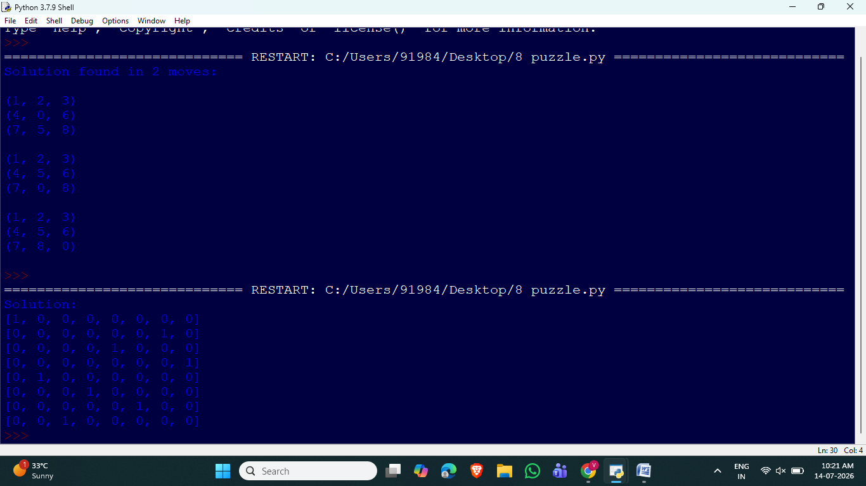

8 Queen Problem

Aim
To write a Python program to solve the 8 Queen Problem using Backtracking.

Algorithm
- Start.
- Create an 8 × 8 chessboard.
- Place queens column by column.
- Check whether the current position is safe.
- If safe, place the queen.
- Otherwise, backtrack and try another position.
- Repeat until all 8 queens are placed.
- Display the solution.
- Stop.
PROGRAM

N = 8
board = [[0] * N for i in range(N)]
def safe(row, col):
for i in range(col):
if board[row][i] == 1:
return False
i, j = row, col
while i >= 0 and j >= 0:
if board[i][j] == 1:
return False
i -= 1
j -= 1
i, j = row, col
while i < N and j >= 0:
if board[i][j] == 1:
return False
i += 1
j -= 1
return True
def solve(col):
if col >= N:
return True
for i in range(N):
if safe(i, col):
board[i][col] = 1
if solve(col + 1):
return True
board[i][col] = 0
return False
if solve(0):
print("Solution:")
for row in board:
print(row)
else:
print("No Solution")

OUTPUT
